**Subject: Discrete Structures** **Quiz**

Name: Section: Roll No.

1. What is the largest number of edges a connected undirected graph with 24 nodes can have?

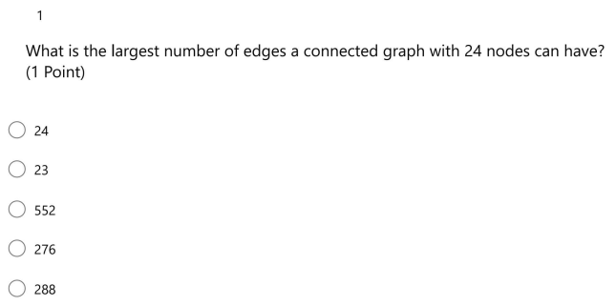

1. Which of the following is a bipartite graph?

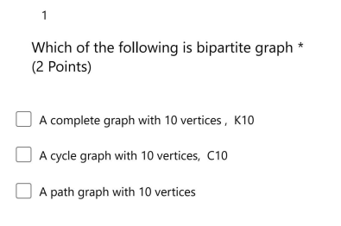

1. Which of the following are bipartite graphs?

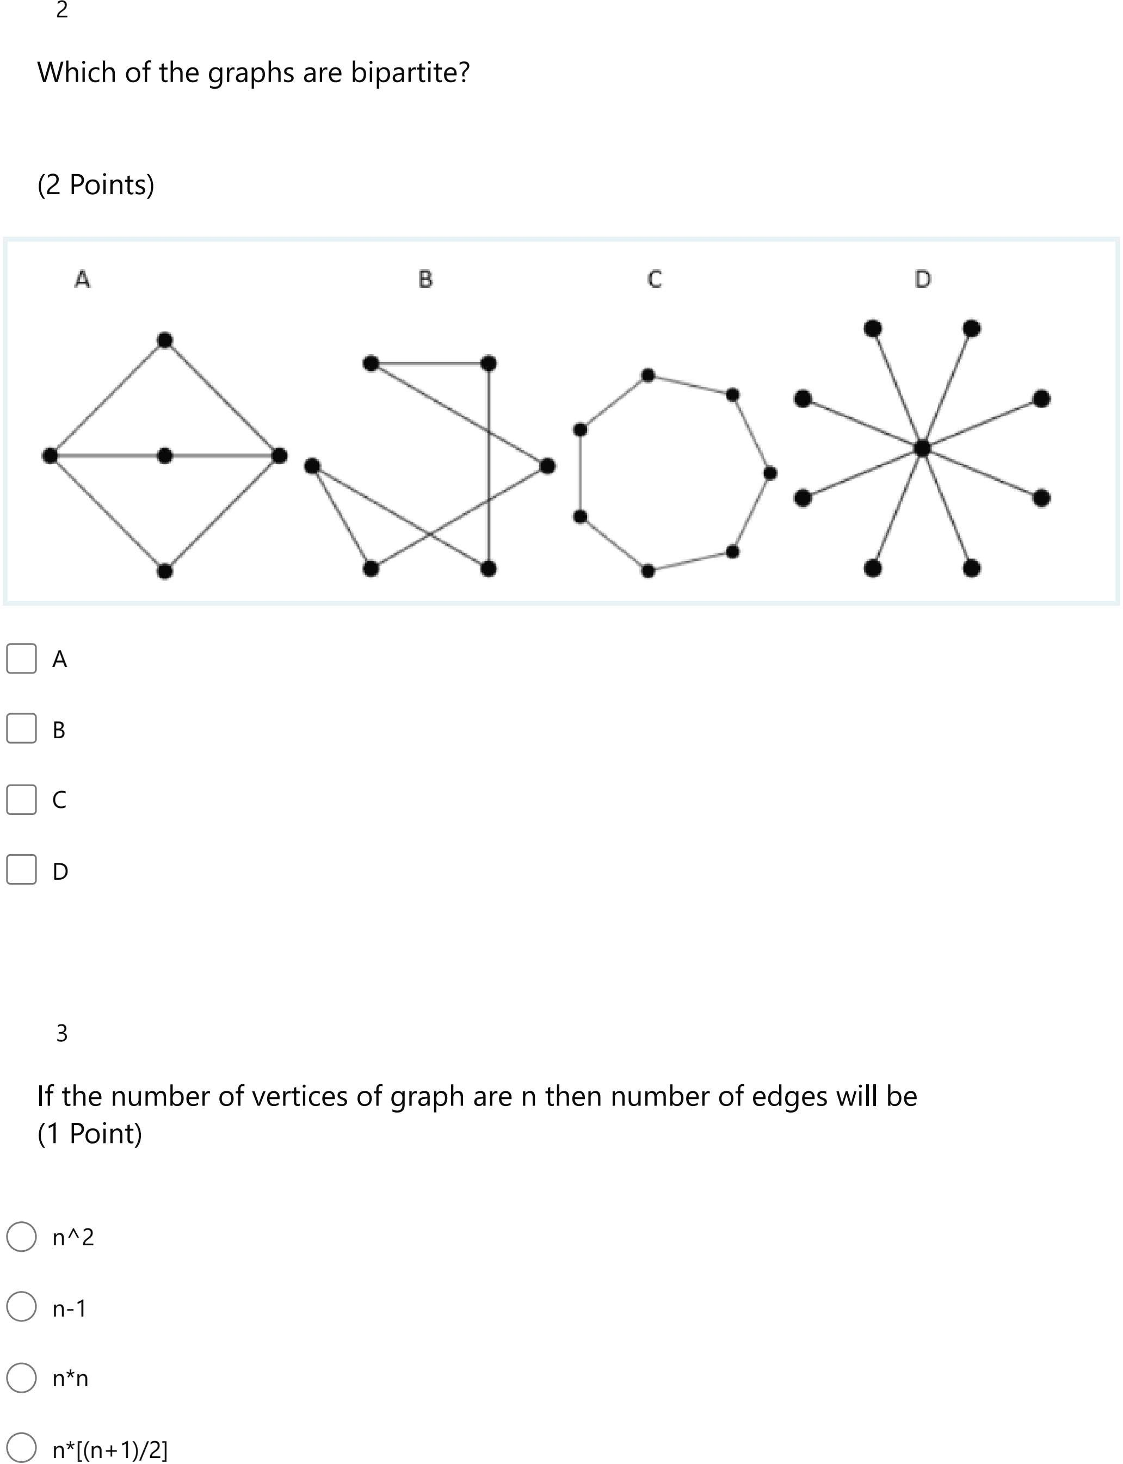

1. Which of the following graphs contain a Euler graph?

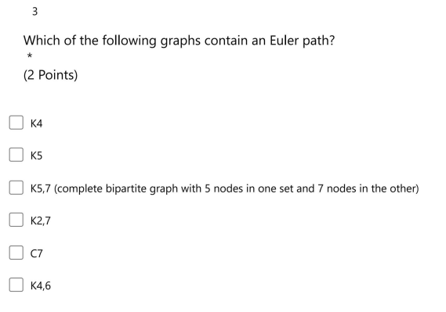

1. Determine whether the following graphs contains a Euler circuit? If yes, then write down the Euler path.

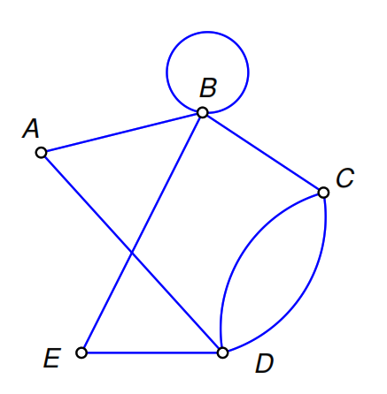 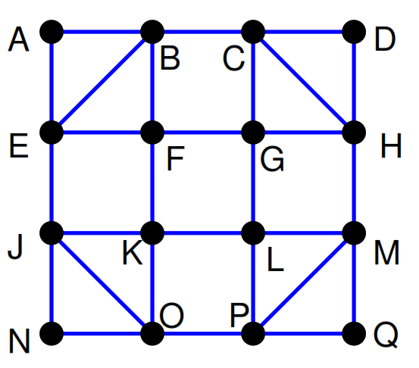

1. Determine whether the following graph contains a Hamiltonian circuit?

